Archimedes’ Principle
Equipment Needed

Clamp, 90°Table Rod 0.75in
Jack, Table Silver
Ring Stand Table Rod Tapered Vertical 0.75inx90cm
Cylinder Set, Specific Heat (w/ hook)
Balance, Ohaus Scout SKX621
AC/DC Adapter Scout SKX621
Hanger for undercarriage weight in AC/DC Adapter box
Digital Scale Support
Graduated Cylinder, 50 ml
Overflow Can, SGT Welch WL1148B
Cup, Measuring (2cup)
Alt. V-Groove Table Top Support Clamp Sargent Welch 470123-510

Purpose
The purpose of this experiment is to investigate Archimedes' principle for an object that is denser than water and an object that is less dense than water.

Introduction
Archimedes' principle states that an object floating or immersed in a fluid is buoyed up by a force equal to the weight of the fluid displaced by the object.
The buoyant force on an object immersed in a liquid can also be determined by weighing an object in air and then in water. The apparent loss of weight of the object is equal to the buoyant force of the water.
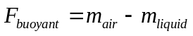
Figure 1
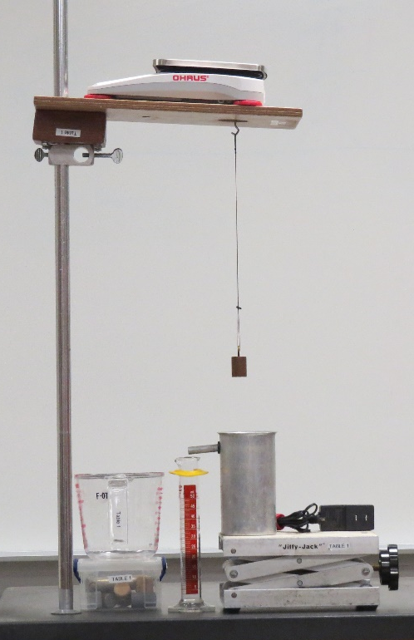

Procedure
Note: We will use grams as "force" units.
- Your initial setup should look like Figure 1. Note: There is an additional method for mounting table rod in Figure 3 at the end of the write-up.
- Before you weigh anything, be sure to zero the Ohaus Scout Balance Scale.
- Find the ‘empty’ weight of the graduated cylinder. This is useful to when dealing with small amounts of water in the cylinder.

Part A - Determine the buoyant force on sample denser than water.
- Attach an object to the platform balance with a light thread as shown in Figure 1.
- Measure and record in Data Table 1A the mass of the specimen.
- Find the mass of the graduated cylinder.
- Use the overflow cup. Fill it with water until water starts coming out of the spout.
- Lower the object into the overflow cup so that it is completely below the surface. While lowering the specimen into the water, catch the runoff water in the graduated cylinder.
- Record the apparent mass of the object while it is submerged.
- Find the upward buoyant "force" exerted on the object by subtracting its mass in water from its mass in air.
- To find the mass of the water displaced by the object, weigh the graduated cylinder with the water in it and subtract the empty weight (from Step 3) from that value.
- Record the mass of the displaced water from the cylinder in Table 1.
- Repeat the above steps for an object made of a different material.

DATA TABLE 1
Trial | Mass of Specimen in Air  (grams) | Apparent Mass of Specimen in Water  (grams) | Apparent Loss  in Mass  (Buoyant "Force") | Mass of Displaced Water
Trial 1
Object 1
Trial 2
Object 2

Questions
- Is the buoyant force equal to the weight of the displaced water? Calculate a percent difference for each trial.
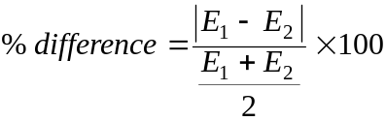
Trial 1 ___________________%
Trial 2 ___________________%
- Why does the specimen appear to weigh less when immersed in water?
Part B - Determine buoyant force on sample less dense than water.
- Using the overflow cup, arrange a sinker and cork so that the sinker is completely below the surface of water while the cork remains in the air. See Figure 2. Fill the cup to the spout and allow the water to quit running out of the spout.

Figure 2
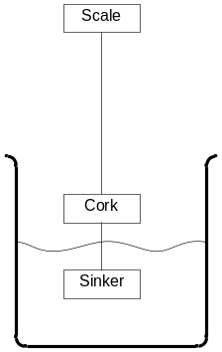

- Carefully find the mass of this setup and record this value in the table as M1.
- Jack up the cup until the sinker and cork are submerged. Catch the water in the graduated cylinder as you do this.
- Record the apparent mass of the submerged cork and sinker as M2.
- Find the upward "force" (buoyant force) exerted on the cork block by subtracting M2 from M1.
- To find the mass of 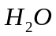 displaced by the cork, weigh the graduated cylinder. You already know its empty weight.
- Record the mass of the displaced water.
DATA TABLE 2
Mass of Specimen in Air and Sinker in Water M1  (grams) | Apparent Mass of Specimen and Sinker in Water M2 (grams) | Apparent Loss in Mass (Buoyant "Force")  M1 - M2 | Mass of Displaced Water  (grams)

Questions
- Is the buoyant force equal to the weight of the displaced water? Calculate a percent difference for the trial.
= ________________ %
- Explain why a ball of clay sinks, but when shaped into a boat it floats.

Figure 3


